project
INTRODUCTION
BookMyShow is one of the most popular online ticket booking platforms used for booking movie tickets, live events, concerts, sports events, and entertainment programs. It provides users with a convenient way to explore available shows and reserve seats through a simple and user-friendly interface.
The objective of this project is to create a frontend clone of the BookMyShow website using HTML, CSS, and JavaScript. The project focuses on designing an attractive user interface and implementing essential functionalities such as movie browsing, searching, seat selection, and booking confirmation.
This project helps in understanding the fundamentals of web development, including webpage structure, styling, responsive layouts, and client-side scripting. The website is designed to provide a smooth user experience while maintaining a simple and easy-to-understand code structure.
OBJECTIVE
The primary objective of this project is to develop a movie ticket booking website inspired by BookMyShow. The website allows users to browse movie listings, search for movies, select preferred seats, and simulate the ticket booking process.
Another objective of the project is to gain practical experience in frontend web development technologies such as HTML, CSS, and JavaScript. The project also helps in understanding user interface design principles and improving problem-solving skills in web application development.
TECHNOLOGIES USED
HTML (HyperText Markup Language) is used to create the structure and content of the website. It defines the layout of pages, headings, images, buttons, forms, and navigation components.
CSS (Cascading Style Sheets) is used to enhance the visual appearance of the website. It is responsible for colors, layouts, spacing, fonts, responsiveness, animations, and hover effects.
JavaScript is used to add interactivity to the website. It handles movie selection, search functionality, seat selection, local storage operations, and booking confirmation messages.
GitHub is used for project version control and repository management. It allows the project to be stored online and shared easily.
PROJECT MODULES
The Home Page serves as the landing page of the website. It contains a navigation bar, banner section, recommended movies section, and popular events section. This page provides users with an overview of the available content.
The Movies Page displays movie cards with movie posters, ratings, and language information. A search functionality is implemented to allow users to quickly find movies based on their names.
The Booking Page allows users to select show timings and seats. Once a seat is selected, users can confirm their booking and receive a booking confirmation message.

FEATURES
The website includes a movie browsing feature that allows users to view multiple movies along with ratings and language details. Movie cards are designed using a clean and modern user interface.
A search functionality is provided to help users locate movies quickly. The search updates the displayed movie list dynamically based on user input.
The booking module allows users to select seats and show timings. JavaScript is used to store the selected movie information and display booking details during confirmation.
The project also includes responsive design principles, hover effects, and an attractive visual layout to improve user experience.
IMPLEMENTATION PROCESS
The development process started with planning the website structure and identifying the required pages. Three main pages were created: Home Page, Movies Page, and Booking Page.
HTML was used to create the page structure, while CSS was used to design the user interface. Different sections such as movie cards, navigation bars, banners, and booking forms were styled to achieve a professional appearance.
JavaScript was implemented to provide interactive functionality. Features such as movie selection, search filtering, seat selection, and booking confirmation were developed and tested.
Finally, movie posters and event images were added to improve the visual appeal of the website. The project was tested on different screen sizes and uploaded to GitHub for submission.
SCREENSHOTS
1. Home Page
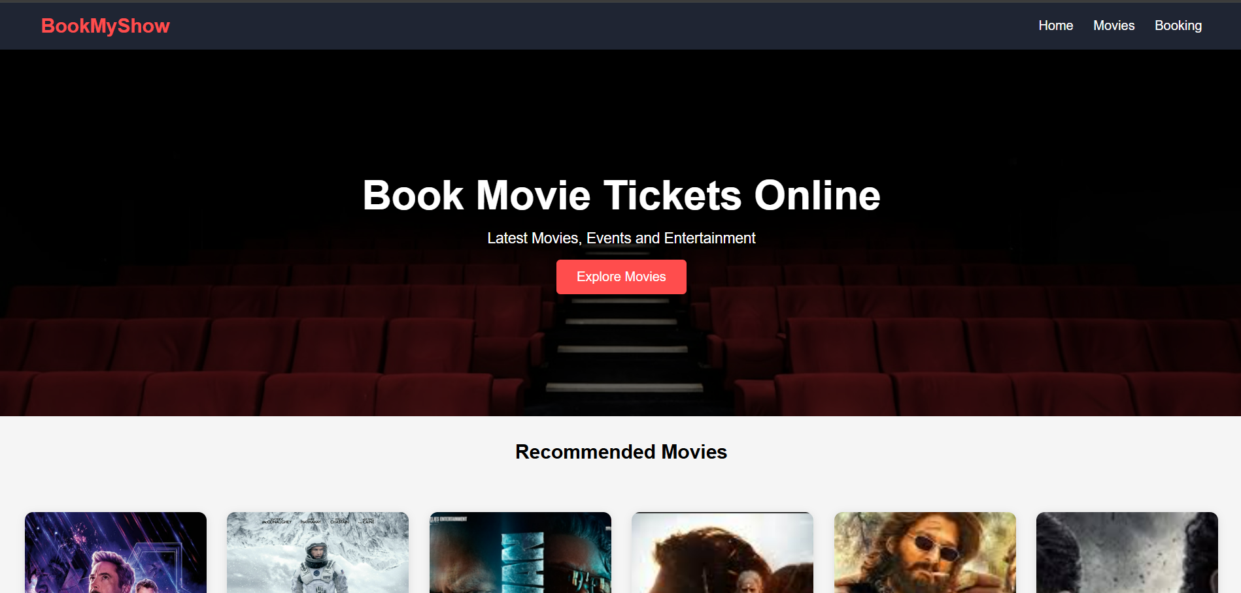Recommended Movies
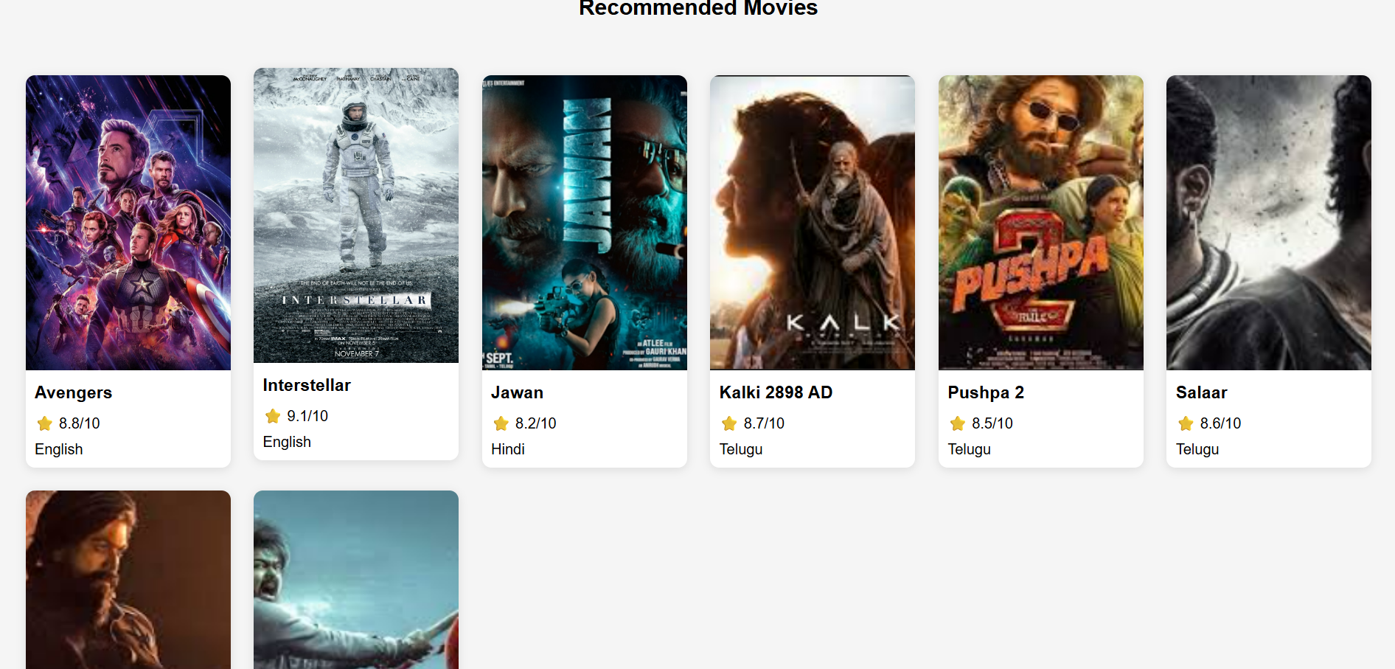Popular Events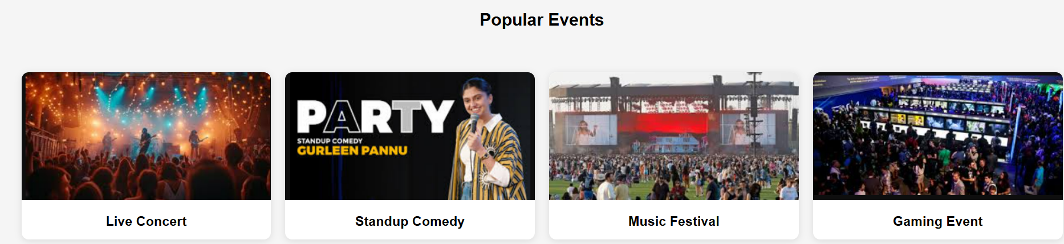2. Movies Page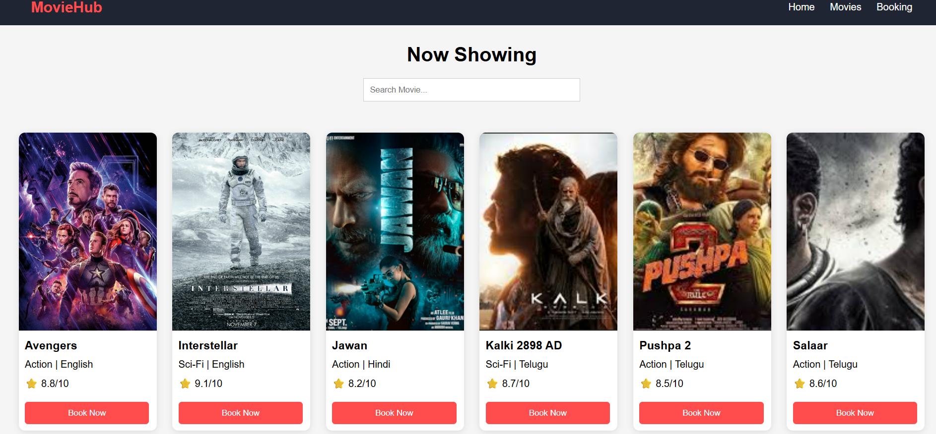3. Search Functionality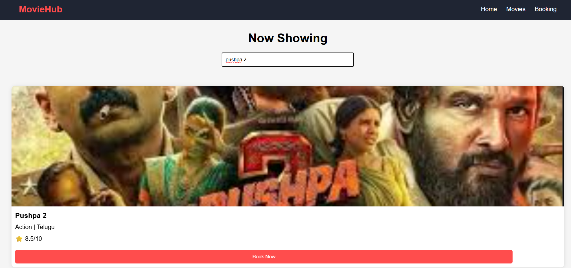4. Booking Page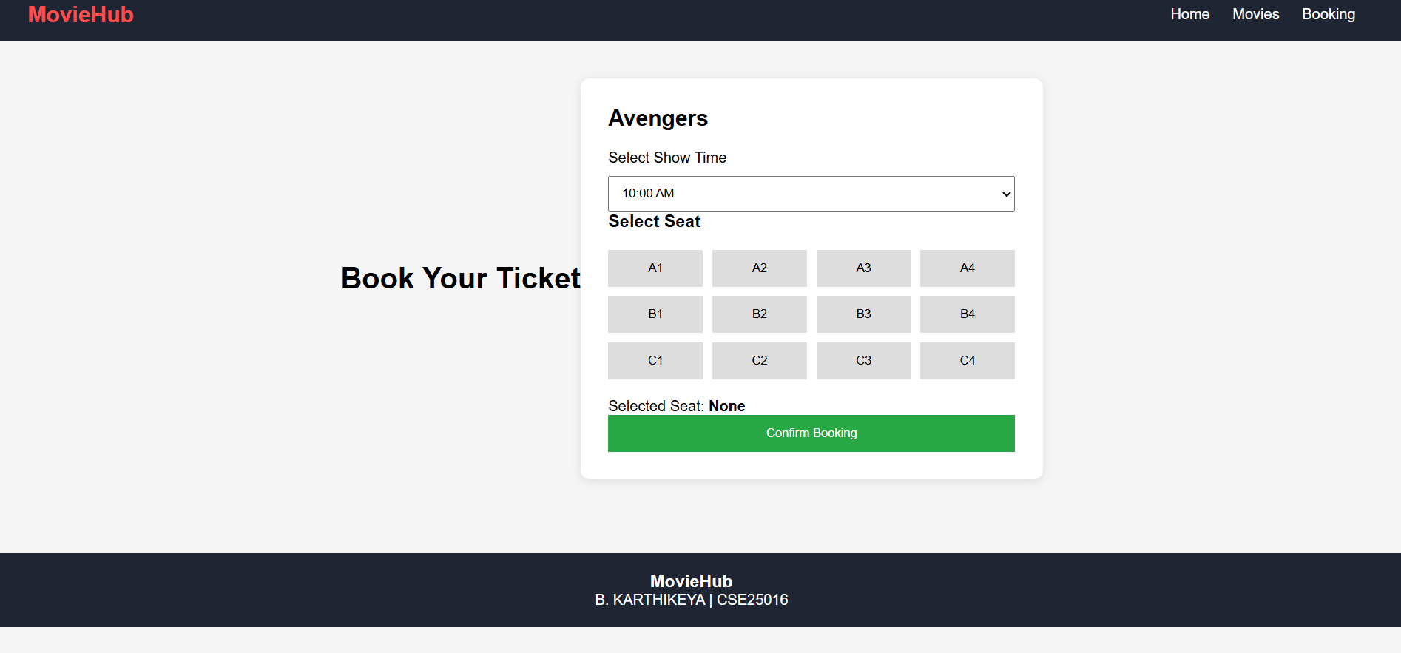5. Seat Selection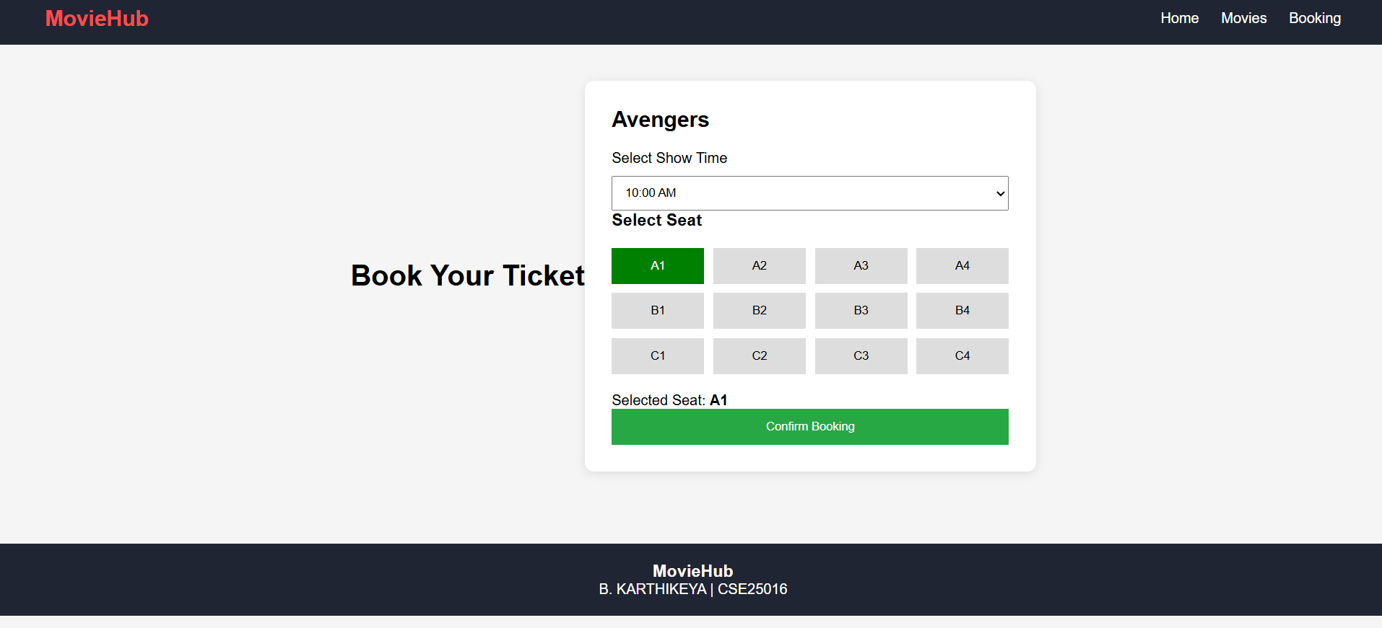6. Booking Confirmation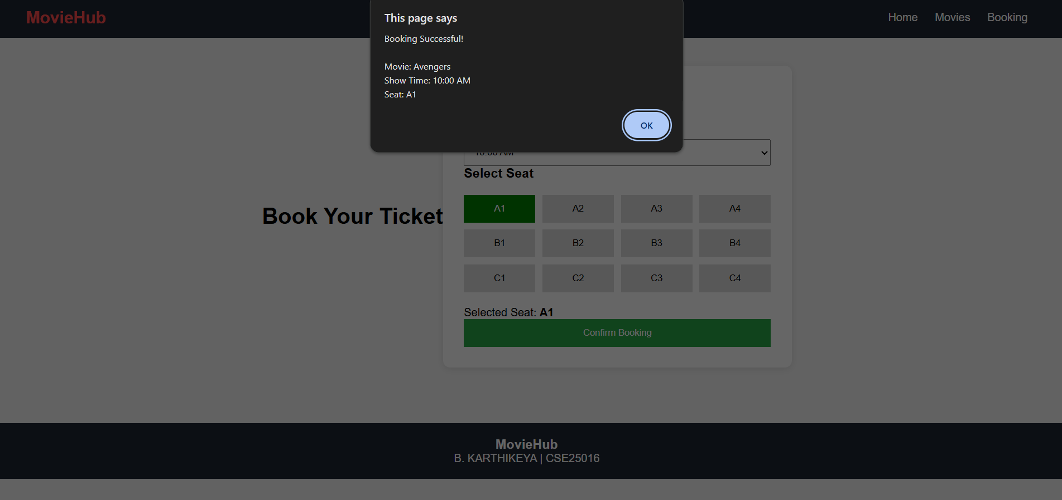
CONCLUSION
The BookMyShow Clone project was successfully designed and developed using HTML, CSS, and JavaScript. The project demonstrates important concepts of frontend web development, including webpage design, responsive layouts, user interaction, and client-side scripting.
The project helped in understanding how real-world booking websites function and provided practical experience in creating interactive web applications. Future enhancements may include user authentication, payment integration, database connectivity, and real-time seat management.

